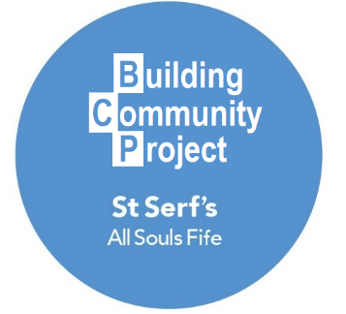

Newly Ordained Priest to Head New Initiative
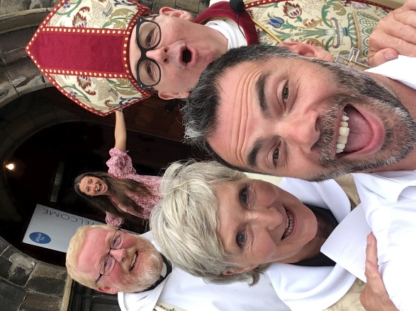
On the 15th July St Serf’s Church on Ferguson Place had a celebration that brought people from all around Scotland. The Rev Carol Latimer was ordained by the Right Reverend Kevin Pearson, the Bishop of Argyll and The Isles of the Scottish Episcopal Church. In Carol’s new role and position she will be serving the All Souls Churches in sacrament, word and action. One focus for Carol will be heading a new initiative entitled The Building Community Project.
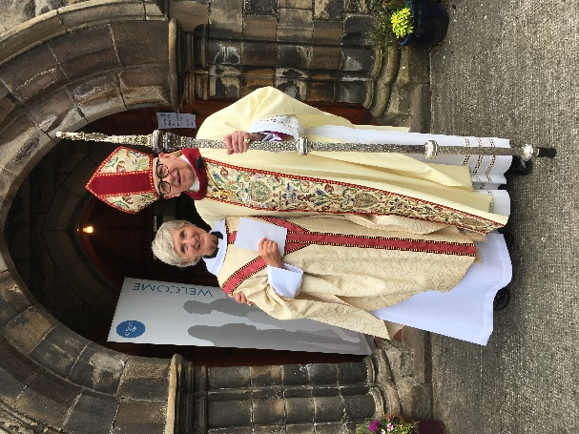
The Building Community Project is what it says on the label and will utilize both the people and the building of St Serf’s to build and enhance the existing community. In the future we intend to use our building for Wee Souls, Arty Souls, Musical Souls, Wise Souls and All Souls. Our motto is ‘Come As You Are’ and we invite you to be involved in the future and to keep an eye out for Carol as she faithfully serves our community and churches.
…connecting friends, families and faith
Charity Number: SC010577

